**COFFEE_SHOP_SALES PROJECT**

**OBJECTIVES: Import, Clean, Analyze and Visualize Dataset**

**QUERIES:**

SELECT *

FROM coffeeshop_sales;-- After checking, I saw I needed to do some data cleaning

**DATA CLEANING**

DESCRIBE coffeeshop_sales;-- From the result , I had the datatype of the transaction date & time column as TEXT instead of DATE and TIME

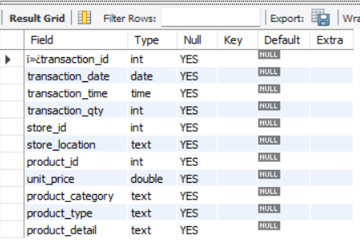

UPDATE coffeeshop_sales

SET transaction_date = str_to_date(transaction_date, '%m/%d/%Y');

ALTER TABLE coffeeshop_sales

MODIFY COLUMN transaction_date DATE;

UPDATE coffeeshop_sales

SET transaction_time = str_to_date(transaction_time, '%H:%i:%s');

ALTER TABLE coffeeshop_sales

MODIFY COLUMN transaction_time TIME;

ALTER TABLE coffeeshop_sales

CHANGE COLUMN ï»¿transaction_id transaction_id INT;-- DATA CLEANING DONE!!!

**KPIs**

**-- 1. TOTAL SALES**

SELECT SUM(transaction_qty * unit_price) Total_Sales

FROM coffeeshop_sales;

/* WHERE

MONTH(transaction_date) = 5;(Add the where clause to filter by months)*/

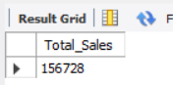

**-- 2.MONTH ON MONTH DIFFERENCE AND MONTH ON MONTH GROWTH IN RESPECT TO SALES**

SELECT

MONTH(transaction_date) AS month,-- Number of Month

ROUND(SUM(unit_price * transaction_qty)) AS total_sales,-- Total Sales Column

(SUM(unit_price * transaction_qty) - LAG(SUM(unit_price * transaction_qty), 1) -- Month Sale Difference

OVER (ORDER BY MONTH(transaction_date))) / LAG(SUM(unit_price * transaction_qty), 1)-- Division by Previous Month Sales

OVER (ORDER BY MONTH(transaction_date)) * 100 AS mom_increase_percentage-- percentage

FROM

coffeeshop_sales

WHERE

MONTH(transaction_date) IN (4, 5) -- for months of April and May

GROUP BY

MONTH(transaction_date)

ORDER BY

MONTH(transaction_date);

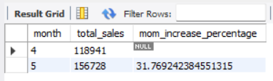

**-- 3.TOTAL ORDERS PER MONTH**

SELECT COUNT(transaction_id) Total_Sales

FROM coffeeshop_sales

WHERE

MONTH(transaction_date) = 3;-- (Add the where clause to filter by months)

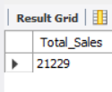

**-- 4.MONTH ON MONTH DIFFERENCE AND MONTH ON MONTH GROWTH IN RESPECT TO ORDERS**

SELECT

MONTH(transaction_date) AS month,

ROUND(SUM(transaction_qty)) AS total_quantity_sold,

(SUM(transaction_qty) - LAG(SUM(transaction_qty), 1)

OVER (ORDER BY MONTH(transaction_date))) / LAG(SUM(transaction_qty), 1)

OVER (ORDER BY MONTH(transaction_date)) * 100 AS mom_increase_percentage

FROM

coffeeshop_sales

WHERE

MONTH(transaction_date) IN (4, 5) -- for April and May

GROUP BY

MONTH(transaction_date)

ORDER BY

MONTH(transaction_date);

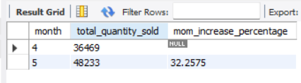

**-- 5.TOTAL QUANTITY SOLD PER MONTH**

SELECT SUM(transaction_qty) Total_Qty_Sold

FROM coffeeshop_sales

WHERE

MONTH(transaction_date) = 5;-- (Add the where clause to filter by months)

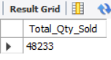

**-- 6.MONTH ON MONTH DIFFERENCE AND MONTH ON MONTH GROWTH IN RESPECT TO QUANTITIES SOLD**

SELECT

MONTH(transaction_date) AS month,

ROUND(SUM(transaction_qty)) AS total_quantity_sold,

(SUM(transaction_qty) - LAG(SUM(transaction_qty), 1)

OVER (ORDER BY MONTH(transaction_date))) / LAG(SUM(transaction_qty), 1)

OVER (ORDER BY MONTH(transaction_date)) * 100 AS MoM_increase_percentage

FROM

coffeeshop_sales

WHERE

MONTH(transaction_date) IN (4, 5) -- for April and May

GROUP BY

MONTH(transaction_date)

ORDER BY

MONTH(transaction_date);



**-- 7.CALENDAR TABLE: DAILY SALES,QUANTITY SOLD AND ORDERS**

SELECT

SUM(unit_price * transaction_qty) AS total_sales,

SUM(transaction_qty) AS total_quantity_sold,

COUNT(transaction_id) AS total_orders

FROM

coffee_shop_sales

WHERE

transaction_date = '2023-05-18'; -- For 18 May 2023

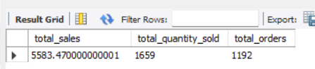

***To get exact Rounded off values then:***

SELECT

CONCAT(ROUND(SUM(unit_price * transaction_qty) / 1000, 1),'K') AS total_sales,

CONCAT(ROUND(COUNT(transaction_id) / 1000, 1),'K') AS total_orders,

CONCAT(ROUND(SUM(transaction_qty) / 1000, 1),'K') AS total_quantity_sold

FROM

coffee_shop_sales

WHERE

transaction_date = '2023-05-18'; --For 18 May 2023

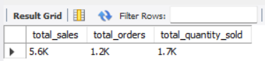

**-- 8.SALES OVER WEEKDAYS AND WEEKENDS**

SELECT

CASE

WHEN DAYOFWEEK(transaction_date) IN (1,7) THEN 'Weekends'

ELSE 'Weekdays'

END AS Period_of_Week,

SUM(unit_price * transaction_qty) AS total_sales

FROM coffeeshop_sales

WHERE MONTH(transaction_date) = 2 -- FEBRUARY

GROUP BY Period_of_Week;

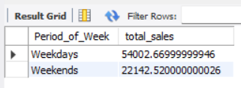

**-- 9.SALES BY STORE LOCATION**

SELECT

store_location,

CONCAT(ROUND(SUM(unit_price * transaction_qty)/1000,1),'K') as Total_Sales

FROM coffeeshop_sales

WHERE

MONTH(transaction_date) = 5

GROUP BY store_location

ORDER BY Total_Sales DESC;

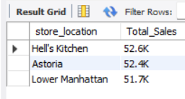

**-- 10.DAILY AVERAGE SAE PERFORMANCE**

SELECT AVG(total_sales) AS avg_sales

FROM (

SELECT

SUM(unit_price * transaction_qty) AS total_sales

FROM

coffeeshop_sales

WHERE

MONTH(transaction_date) = 5 -- Filter for May

GROUP BY

transaction_date

) AS AVGSales;

***Explanation:***

* This inner subquery calculates the total sales (unit_price * transaction_qty) for each date in May. It filters the data to include only transactions that occurred in May by using the MONTH() function to extract the month from the transaction_date column and filtering for May (month number 5).
* The GROUP BY clause groups the data by transaction_date, ensuring that the total sales are aggregated for each individual date in May.
* The outer query calculates the average of the total sales over all dates in May. It references the result of the inner subquery as a derived table named internal_query.
* The AVG() function calculates the average of the total_sales column from the derived table, giving us the average sales for May.

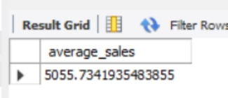

-- 11.DAILY SALES PER MONTH

SELECT

DAY(transaction_date) AS day_of_month,

ROUND(SUM(unit_price * transaction_qty),1) AS total_sales

FROM

coffeeshop_sales

WHERE

MONTH(transaction_date) = 5 -- Filter for May

GROUP BY day_of_month

ORDER BY day_of_month;

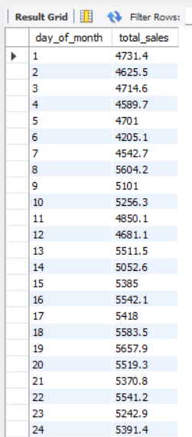

-- 12.DAILY SALES VS AVERAGE SALES – IF GREATER THAN “ABOVE AVERAGE” and LESSER THAN “BELOW AVERAGE”

SELECT

day_of_month,

CASE

WHEN total_sales > avg_sales THEN 'Above Average'

WHEN total_sales < avg_sales THEN 'Below Average'

ELSE 'Average'

END AS sales_status,

total_sales

FROM (

SELECT

DAY(transaction_date) AS day_of_month,

SUM(unit_price * transaction_qty) AS total_sales,

AVG(SUM(unit_price * transaction_qty)) OVER () AS avg_sales

FROM

coffeeshop_sales

WHERE

MONTH(transaction_date) = 5 -- Filter for May

GROUP BY

DAY(transaction_date)

) AS sales_data

ORDER BY

day_of_month;

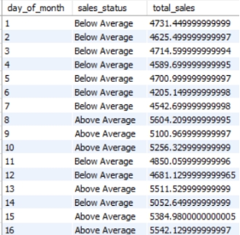 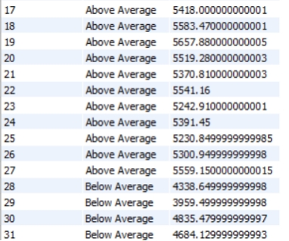

**-- 13.SALES BY PRODUCT CATEGORY**

SELECT

product_category,

ROUND(SUM(unit_price * transaction_qty),1) as Total_Sales

FROM coffee_shop_sales

WHERE

MONTH(transaction_date) = 5

GROUP BY product_category

ORDER BY SUM(unit_price * transaction_qty) DESC;

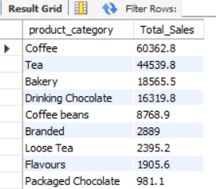

**-- 13.SALES BY PRODUCT TYPE**

SELECT

product_type,

ROUND(SUM(unit_price * transaction_qty),1) as Total_Sales

FROM coffeeshop_sales

WHERE

MONTH(transaction_date) = 5

GROUP BY product_type

ORDER BY SUM(unit_price * transaction_qty) DESC

LIMIT 10;

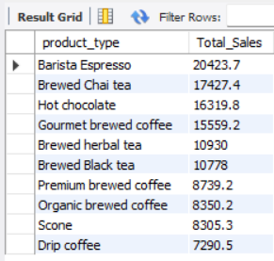

**-- 14.SALES BY HOUR**

SELECT

ROUND(SUM(unit_price * transaction_qty)) AS Total_Sales,

SUM(transaction_qty) AS Total_Quantity,

COUNT(*) AS Total_Orders

FROM

coffeeshop_sales

WHERE

DAYOFWEEK(transaction_date) = 3 -- Filter for Tuesday (1 is Sunday, 2 is Monday, ..., 7 is Saturday)

AND HOUR(transaction_time) = 8 -- Filter for hour number 8

AND MONTH(transaction_date) = 5; -- Filter for May (month number 5)

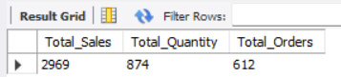

**-- 15.TOTAL SALES BY WEEKDAYS**

SELECT

CASE

WHEN DAYOFWEEK(transaction_date) = 2 THEN 'Monday'

WHEN DAYOFWEEK(transaction_date) = 3 THEN 'Tuesday'

WHEN DAYOFWEEK(transaction_date) = 4 THEN 'Wednesday'

WHEN DAYOFWEEK(transaction_date) = 5 THEN 'Thursday'

WHEN DAYOFWEEK(transaction_date) = 6 THEN 'Friday'

WHEN DAYOFWEEK(transaction_date) = 7 THEN 'Saturday'

ELSE 'Sunday'

END AS Day_of_Week,

ROUND(SUM(unit_price * transaction_qty)) AS Total_Sales

FROM

coffeeshop_sales

WHERE

MONTH(transaction_date) = 5 -- Filter for May (month number 5)

GROUP BY Day_of_Week;

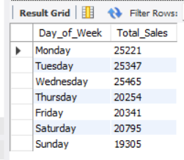

**-- 16.SALES FOR ALL HOURS FOR A SELECTED MONTH**

SELECT

HOUR(transaction_time) AS Hour_of_Day,

ROUND(SUM(unit_price * transaction_qty)) AS Total_Sales

FROM

coffeeshop_sales

WHERE

MONTH(transaction_date) = 5 -- Filter for May (month number 5)

GROUP BY

HOUR(transaction_time)

ORDER BY

HOUR(transaction_time);

